1. Bag of words (BoW) and distances
2. A: [1,1,1,1,0,1,0]

B: [1,1,2,1,1,2,0]

C: [1,0,1,0,0,1,1,]

1. L1 distance between A and B: |1-1|+|1-1|+|1-2|+|1-1|+|0-1|+|1-2|+|0-0|=3

L1 distance between A and C: |1-1|+|1-0|+|1-1|+|1-0|+|0-0|+|1-1|+|0-1|=3

1. L1 normalization of A, B and C:

Sum of A: |1|+|1|+|1|+|1|+|0|+|1|+|0|=5

A = [1/5, 1/5, 1/5, 1/5, 0, 1/5, 0]

Sum of B: |1|+|1|+|2|+|1|+|1|+|2|+|0| = 8

B = [1/8, 1/8, 1/4, 1/8, 1/8, 1/4, 0]

Sum of C: |1|+|0|+|1|+|0|+|0|+|1|+|1|= 4

C=[1/4, 0, 1/4, 0, 0, 1/4, 1/4]

L1 distance between A and B: |1/5-1/8|+|1/5-1/8|+|1/5-1/4|+|1/5-1/8|+|0-1/8|+|1/5-1/4|+|0-0|=9/20

L2 distance between A and C: |1/5-1/4|+|1/5-0|+|1/5-1/4|+|1/5-0|+|0-0|+|1/5-1/4|+|0-1/4|=4/5

1. Histogram and Parzen window
2. First histogram

A = [0,4,0,4,0]

L1-normalized histogram = [0,1/2,0,1/2,0]

B = [2,0,4,0,2]

L1-normalized histogram= [1/4, 0, 1/2, 0, 1/4]

L1 distance between A and B: |0-1/4|+|1/2-0|+|0-1/2|+|1/2-0|+|0-1/4|=2

1. Offset histogram:

A = [2,2,2,2]

L1-normalized histogram = [1/4, 1/4, 1/4, 1/4]

B = [2,2,2,2]

L1-normalized histogram = [1/4, 1/4, 1/4, 1/4]

L1 distance between A and B: |1/4-1/4|+|1/4-1/4|+|1/4-1/4|+|1/4-1/4|=0

1. Narrow bin histogram:

A = [0,2,2,0,0,2,2,0]

L1-normalized histogram = [0, 1/4, 1/4, 0, 0, 1/4, 1/4, 0]

B = [2,0,0,2,2,0,0,2]

L1-normalized histogram = [1/4, 0, 0, 1/4, 1/4, 0, 0, 1/4]

L1 distance between A and B: |0-1/4|+|1/4-0|+|1/4-0|+|0-1/4|+|0-1/4|+|1/4-0|+|1/4-0|+|0-1/4|=2

1. Kernel Density Estimation

p(u=1.5) = 1/8\*(k(1.2-1.5)+k(1.4-1.5)+ k(1.6-1.5)+ k(1.8-1.5)+ k(3.2-1.5)+ k(3.4-1.5)+ k(3.6-1.5)+ k(3.8-1.5))=1/8\*(0.8+1.6+1.6+0.8)=0.6

p(u=2.5) = 1/8\*(k(1.2-2.5)+k(1.4-2.5)+k(1.6-2.5)+k(1.8-2.5)+k(3.2-2.5)+k(3.4-2.5)+k(3.6-2.5)+k(3.8-2.5))=1/8\*(0+0+0+0+0+0+0+0)=0

1. Covariance, z-score, whitening, and PCA
2. Covariance

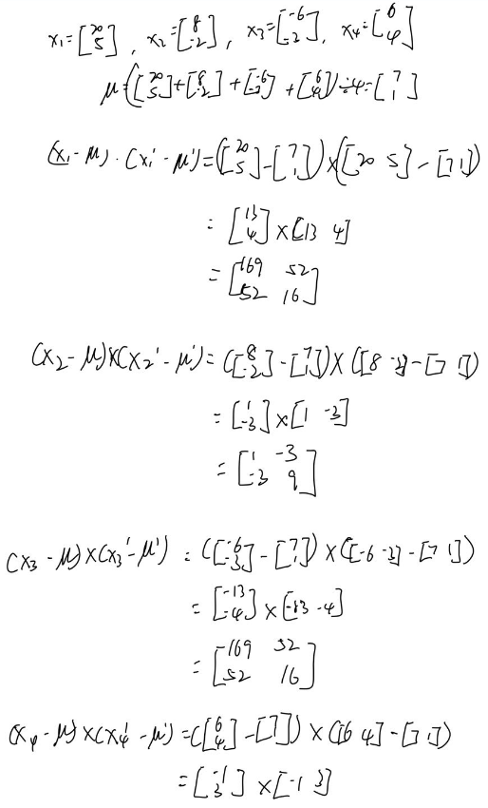

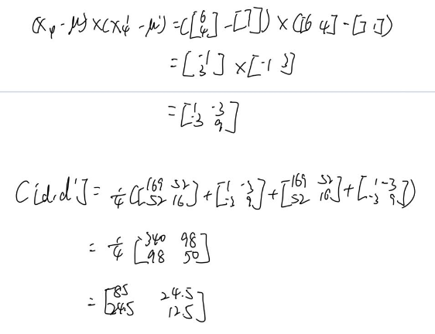

1. Z-score normalization

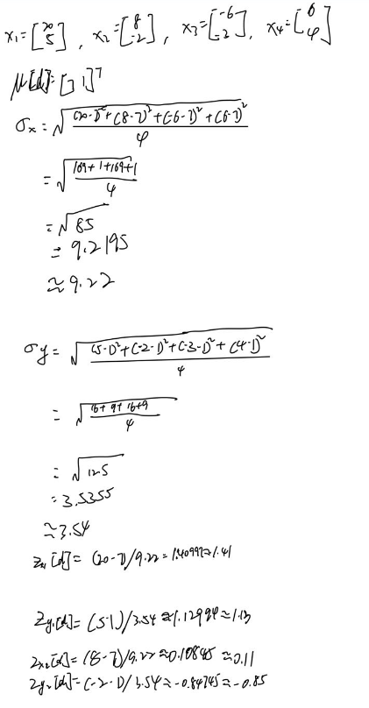

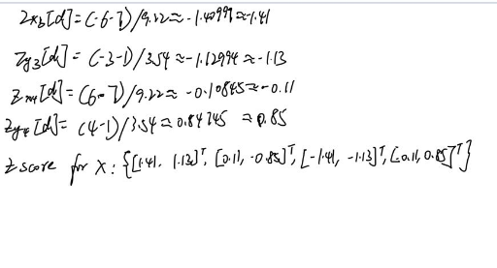

1. Unbiased and uniformly scaled

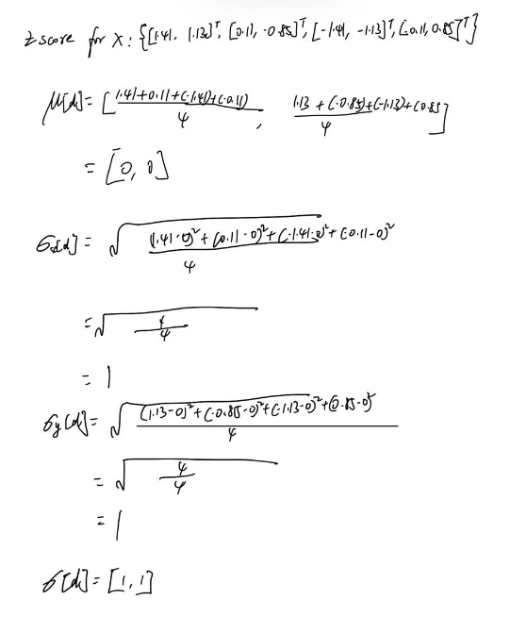

1. Whitening

